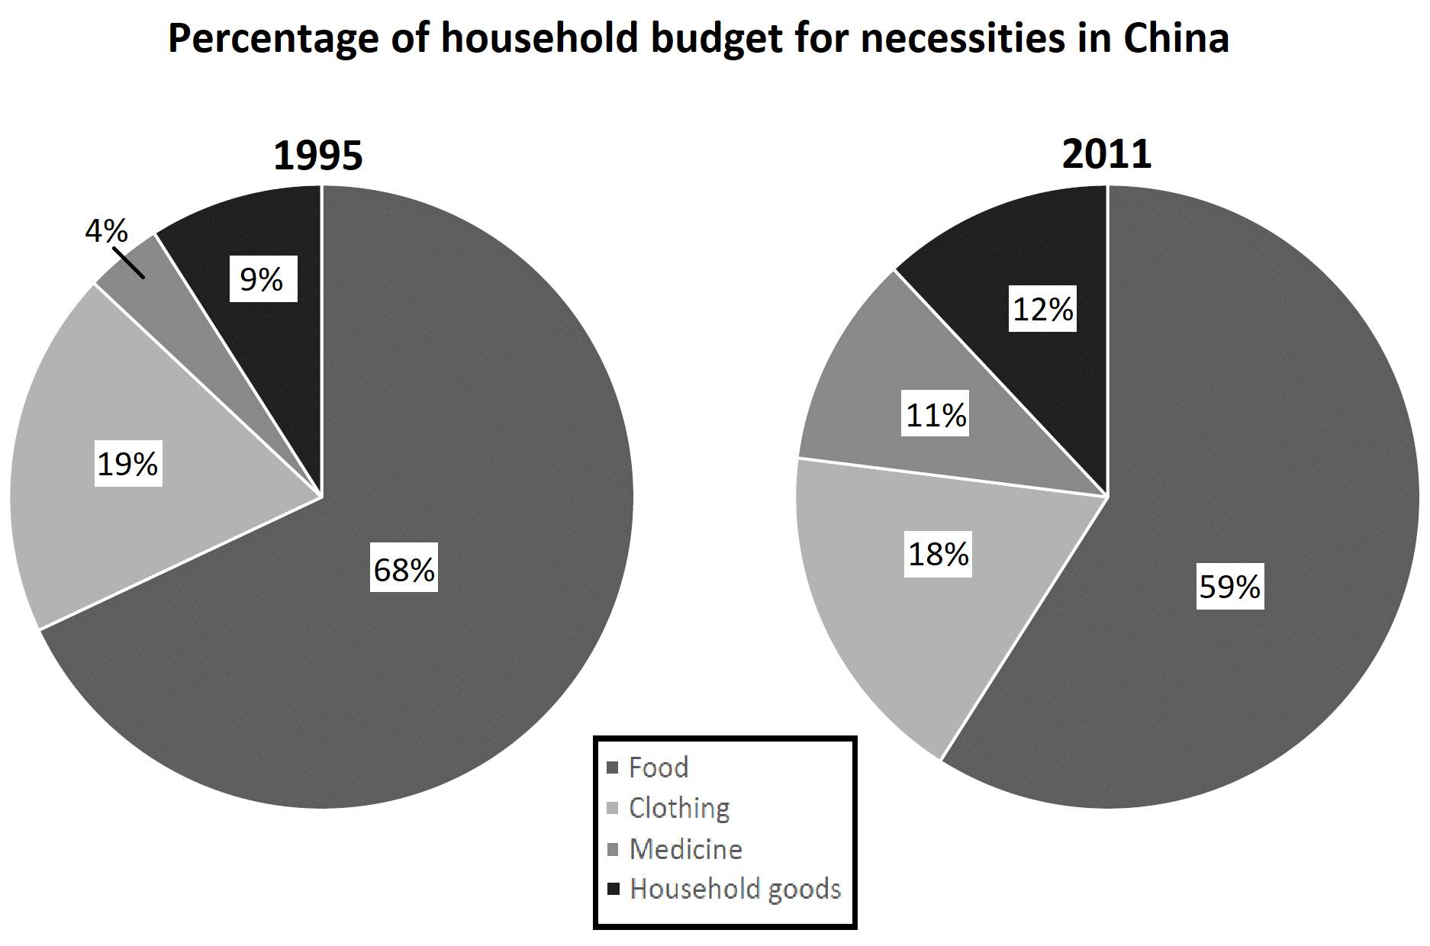

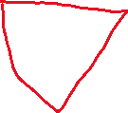

The two pie graphs show differences in Chinese household spending in four essential categories. These categories are marked as percentages of total spending, with differences in spending for 1995 and 2011.

Food and clothing remained the largest categories in both years, with medicine and household goods remaining the smallest. Nonetheless, there were measurable changes in all four categories over the years. Changes to the household budget shares of food and medicine were particularly noticeable.

Both of the top two categories, clothing and food, shrank during this 16 year period. Clothing lost just 1% of its share, going from 19% to 18%, while food dropped more dramatically, starting at 68% but losing 9 points of share by 2011.

In both 1995 and 2011, medicine and household goods represented the lowest and second-lowest spending categories, respectively. Still, both gained a larger share of household spending in China by 2011. Medicine jumped 7 points from 4% to 11%, while household goods made a smaller but still-noticeable increase from 9 to 12 percent.